Day 2 – Understanding the Internet
Date: July 4, 2026

1. Internet Architecture
Internet architecture is the overall structure that enables billions of devices worldwide to communicate with each other.

Components
- Client (User Device)
- Internet Service Provider (ISP)
- Routers
- DNS Servers
- Web Servers
- Datacenters

Communication Flow
User
→ ISP
→ DNS Server
→ Internet
→ Web Server
→ Response Back to User

2. IP Address
An IP (Internet Protocol) address is a unique numerical identifier assigned to every device connected to a network.
Example: 192.168.1.1
Purpose
- Device identification
- Location on a network
- Routing Internet traffic
Types
- Public IP
- Private IP
- Static IP
- Dynamic IP

3. DNS (Domain Name System)
DNS translates human-readable domain names into IP addresses. DNS is the phonebook of the internet. It changes names like wikipedia.org into the right IP address.
Example
wikipedia.org
↓

208.xx.xx.xx (example representation)
Without DNS, users would have to remember numerical IP addresses instead of website names.

4. HTTP
HTTP (HyperText Transfer Protocol) is the protocol used to transfer web pages between browsers and web servers. HTTP is the basic rule that lets your browser talk to websites and load pages.
Characteristics
- Stateless
- Request–Response Model
- Port 80
Common Methods
- GET
- POST
- PUT
- DELETE

5. HTTPS
HTTPS is the secure version of HTTP — it encrypts data so it’s safe from hackers.
Features
- Encrypts communication
- Uses SSL/TLS certificates
- Prevents data interception
- Protects user privacy
Default Port
443

6. URL Structure
A URL is a web address. Example: https://en.wikipedia.org/wiki/Internet → protocol (https), domain (wikipedia.org), path (/wiki/Internet).
Example: https://en.wikipedia.org/wiki/OpenAI?oldid=12345#History
Components
Protocol: https
Subdomain:en
Domain: wikipedia.org
Path: /wiki/OpenAI
Query Parameter: oldid=12345
Fragment: History

7. Surface Web
The Surface Web contains webpages indexed by search engines. The surface web is what we use daily — sites like Google, YouTube, Wikipedia.
Examples
- Wikipedia
- News websites
- Government websites
- Company websites

8. Deep Web
The Deep Web contains content that search engines cannot index. The deep web is hidden content like databases, emails, or private records. Not bad, just not searchable.
Examples
- Email inboxes
- Banking portals
- Medical records
- University databases
- Private cloud storage

9. Dark Web
The dark web is a small part of the deep web, accessed with special browsers, often linked to illegal activity but also used for privacy.
Characteristics
- Uses .onion domains
- Provides anonymity
- Used for privacy and research
- Also hosts illegal activities
Important Note
Accessing the Dark Web requires caution and should only be done ethically and legally.

Wikipedia Investigation Report :
Subject: Wikipedia

Executive Summary
Wikipedia is one of the world’s largest free online encyclopedias, collaboratively written by volunteers and operated by the Wikimedia Foundation. It provides information on millions of topics in multiple languages, making it a vital OSINT source for background research.

Website Overview
- Website Name: Wikipedia
- Organization: Wikimedia Foundation
- Website: https://www.wikipedia.org/
- Launched: January 15, 2001
- Founders: Jimmy Wales & Larry Sanger
- Purpose: Free, publicly accessible knowledge worldwide

DNS Report
- Domain: wikipedia.org
- Purpose: Maps the domain name to IP addresses via DNS
- Observed Information:
  - Multiple IP addresses through global infrastructure
  - Protected using HTTPS
  - DNS enables nearest server access
DNS Importance:
- Converts names into IP addresses
- Improves reliability
- Supports global content delivery

URL Breakdown
Example URL: https://en.wikipedia.org/wiki/OpenAI

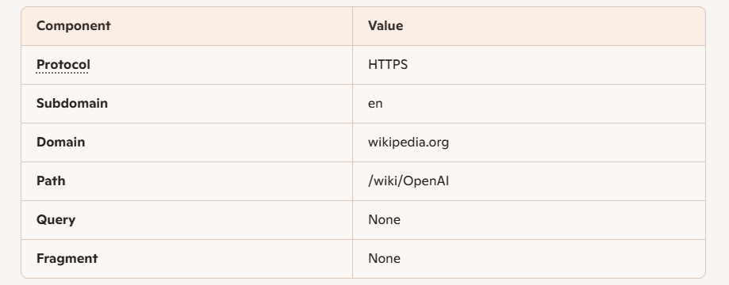

Website Architecture Notes
Flow of Access:
- User Browser
- DNS Lookup
- Wikipedia Server
- Database
- Page Generation
- HTTPS Response
- Browser Displays Content
Architecture Components:
- Client Browser
- DNS Server
- Web Server
- Application Layer
- Database
- HTTPS Encryption

Security Features
- HTTPS encryption
- SSL/TLS certificates
- Global content delivery infrastructure
- Public editing with moderation
- Revision history for transparency
OSINT Value
Wikipedia is valuable for:
- Initial background research
- Historical information
- Organizational profiles
- Public references
- Cross-referencing with primary sources
Information from Wikipedia should always be verified with official or authoritative sources before being used in professional intelligence reports.
Findings
- Wikipedia is a publicly accessible encyclopedia.
- It uses HTTPS to secure communications.
- DNS resolves its domain to globally distributed servers.
- Its URL structure is simple and descriptive.
- It serves as a useful starting point for OSINT investigations but should not be treated as the final authoritative source.
Conclusion
This investigation demonstrated how Internet technologies—including DNS, IP addressing, HTTP/HTTPS, and URL structures—work together to deliver web content. Examining Wikipedia provided a practical understanding of website architecture and reinforced the importance of validating publicly available information during OSINT investigations.

